ASSIGNMENT-02

1. **Data Module Creation:**

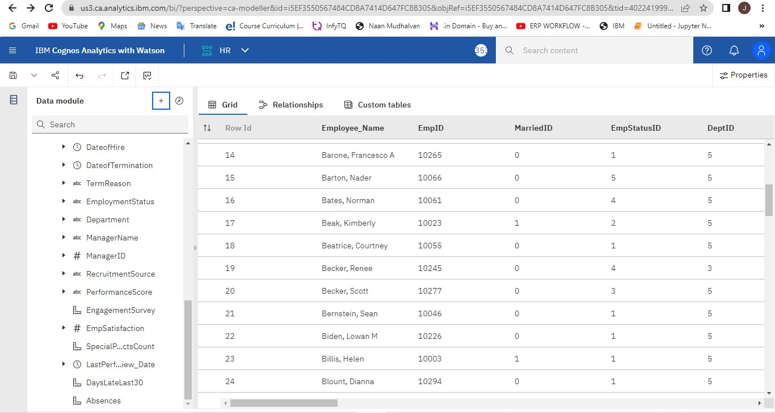

1. **Cleaning Data:**

Unnessary Column (GenderID is deleted as we already have Sex):

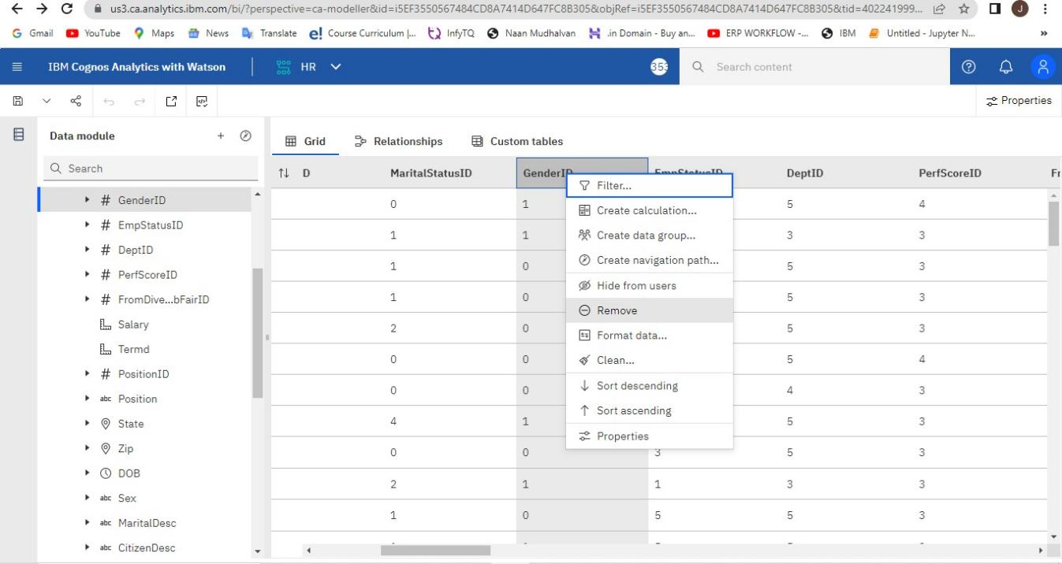

Unnessary Column (MaritalStatusID deleted as we already have MaritalDesc):

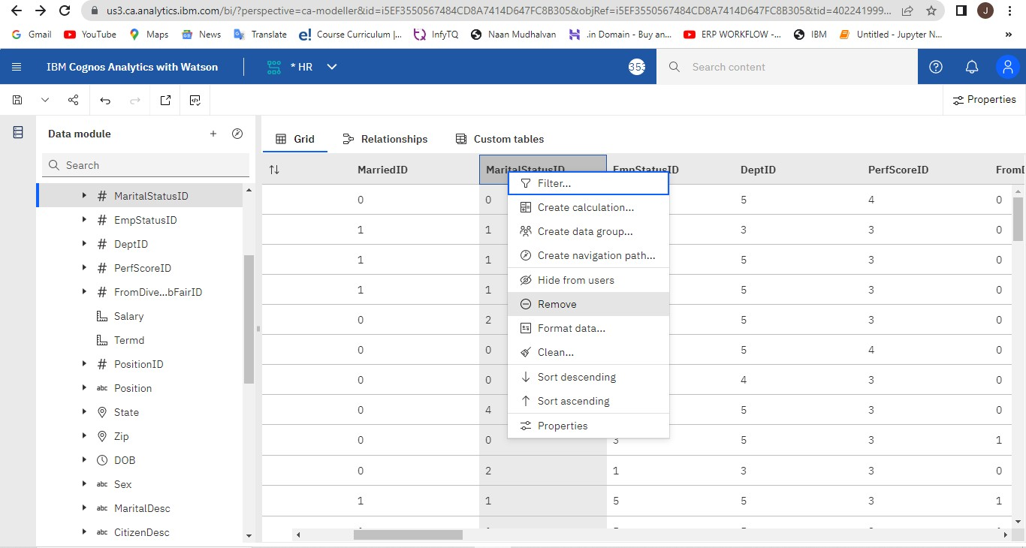

Unnessary Column (DeptID deleted as we already have Department):

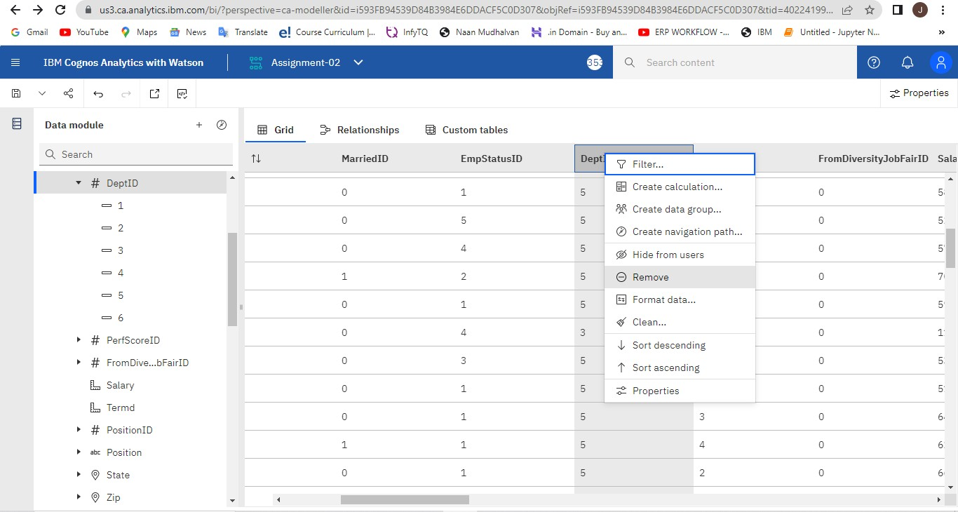

Unnessary Column (PositionID deleted as we already have Position):

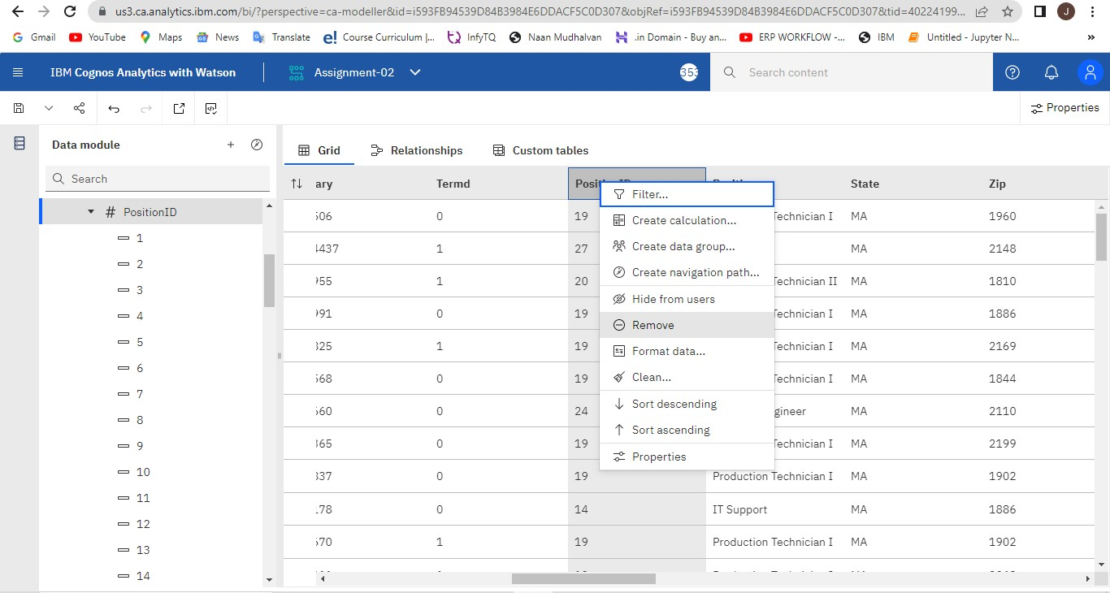

Unnessary Column (PerfScoreID deleted as we already have PerformanceScore):

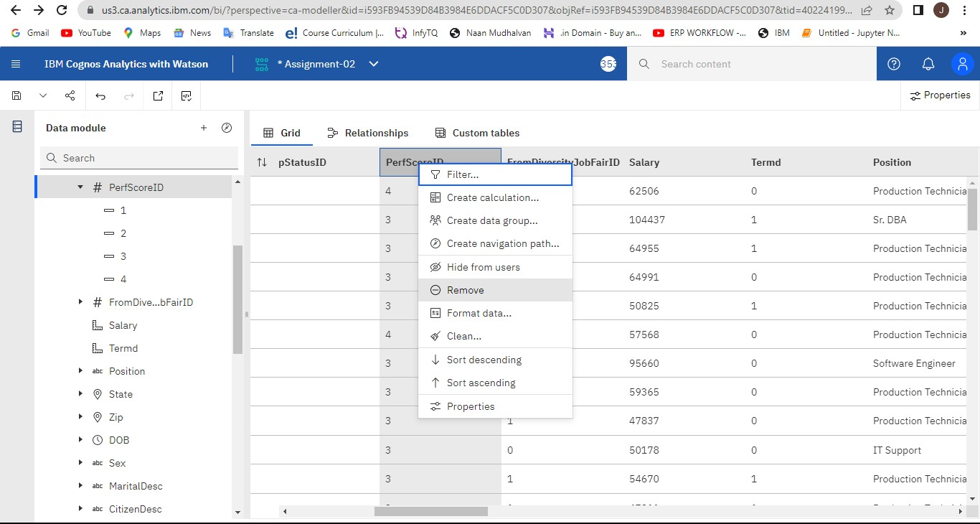

1. **Dataset Visualization & Exploration:**

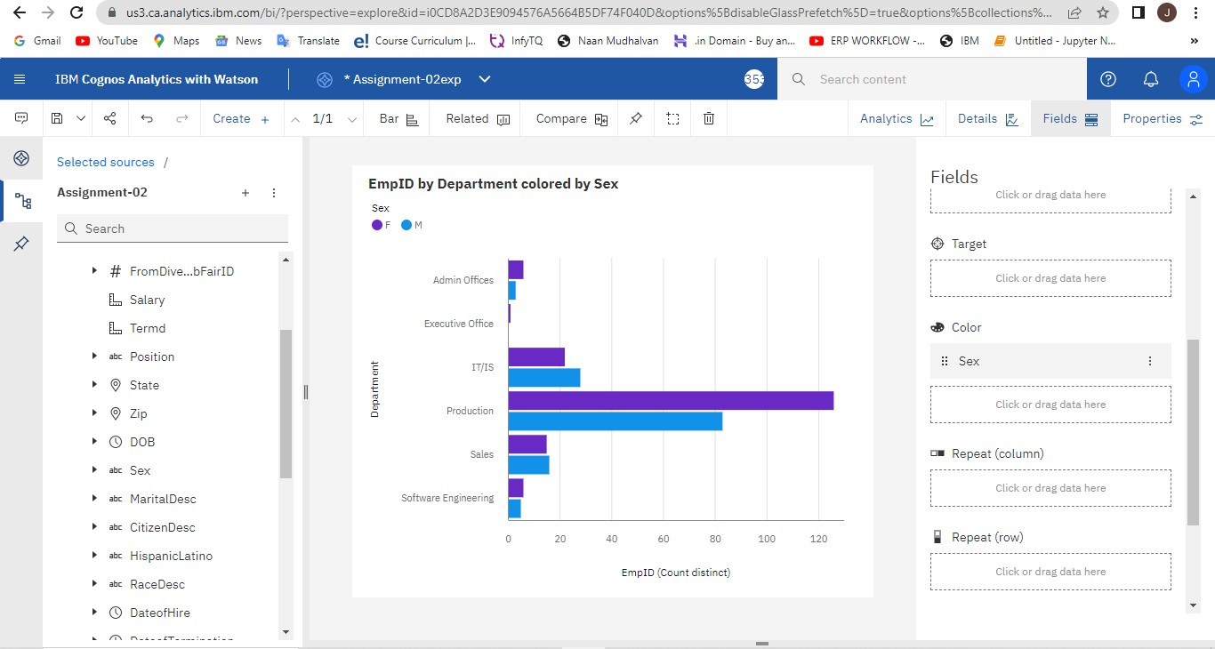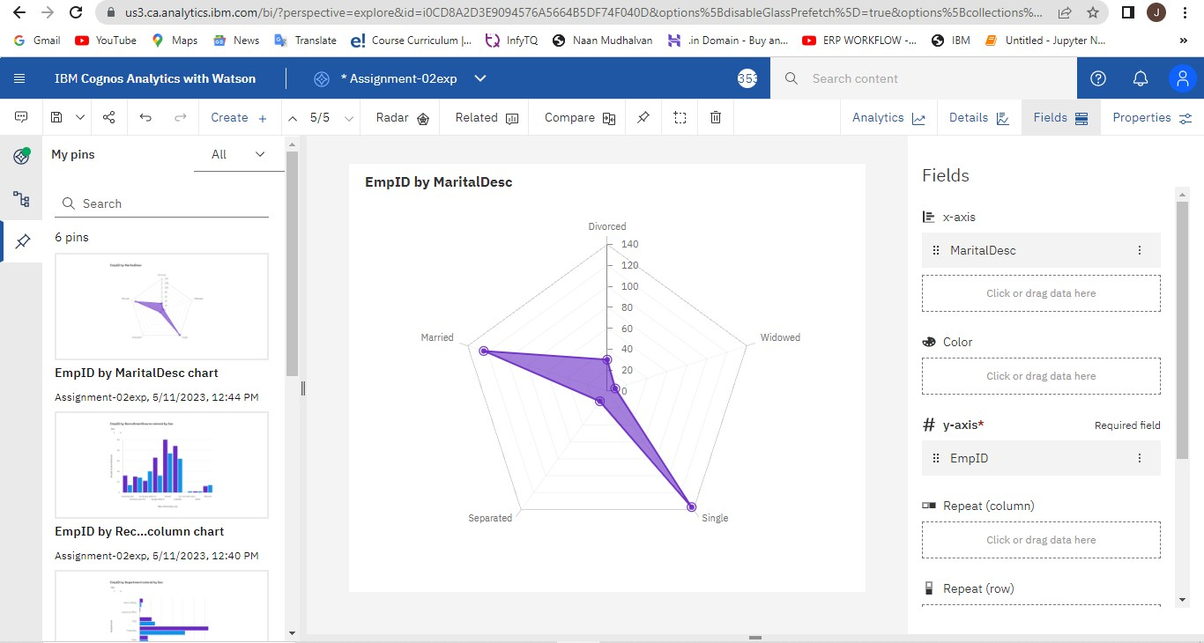

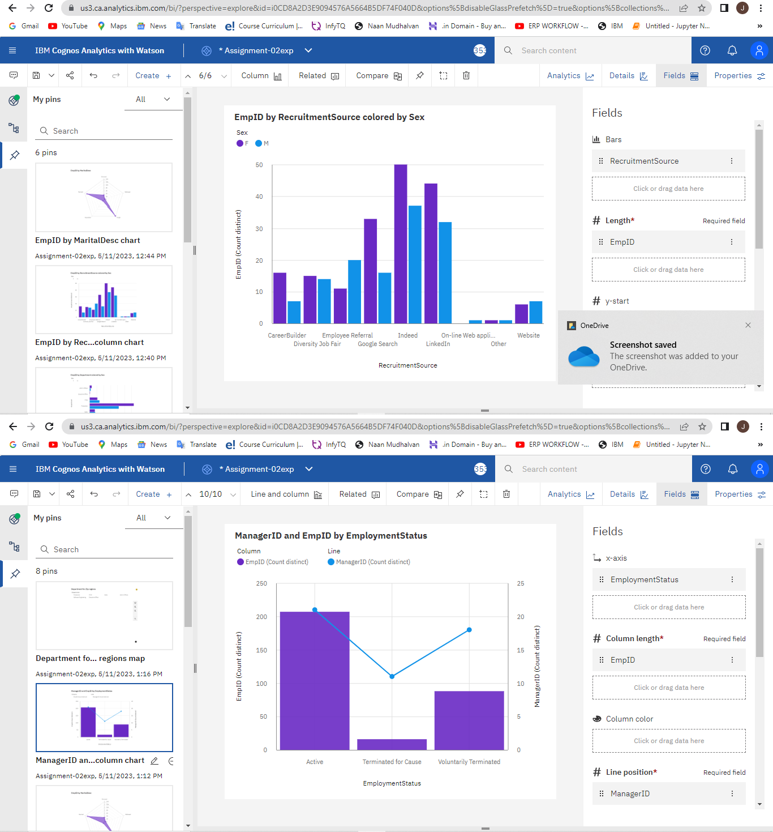

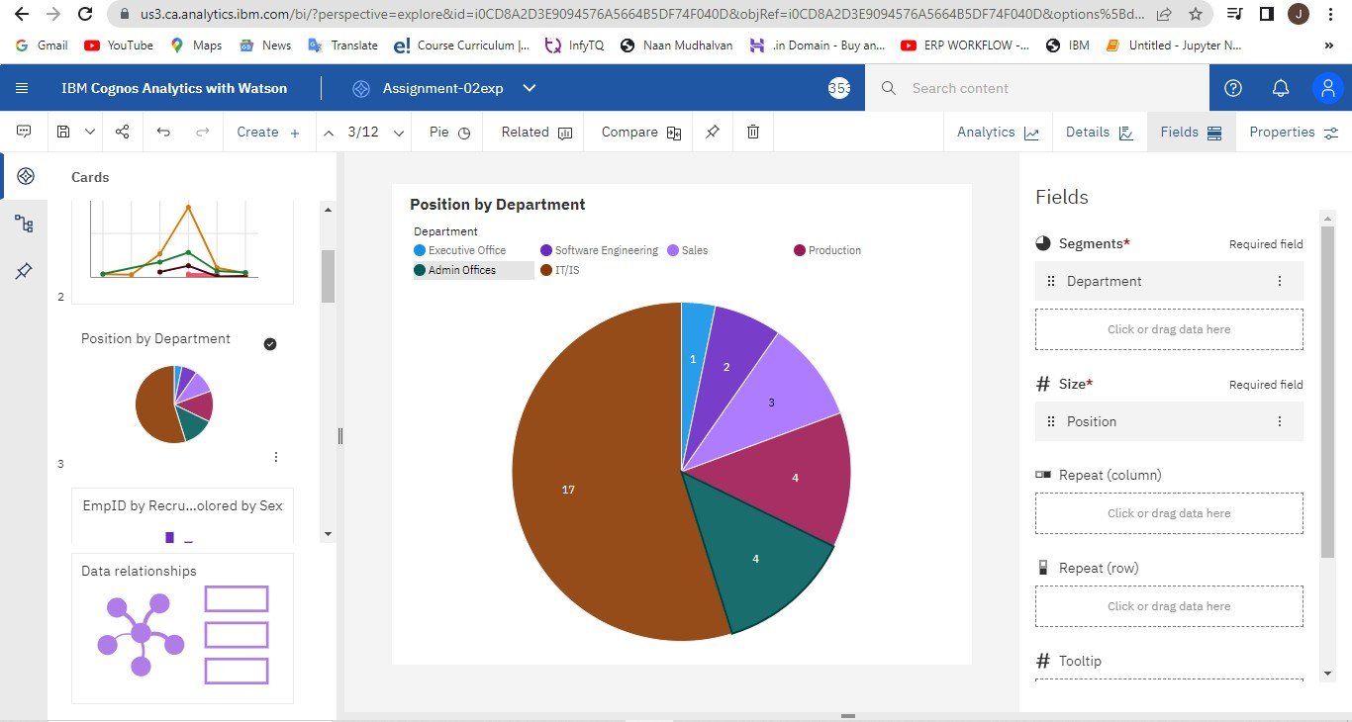

1. **Create Story**

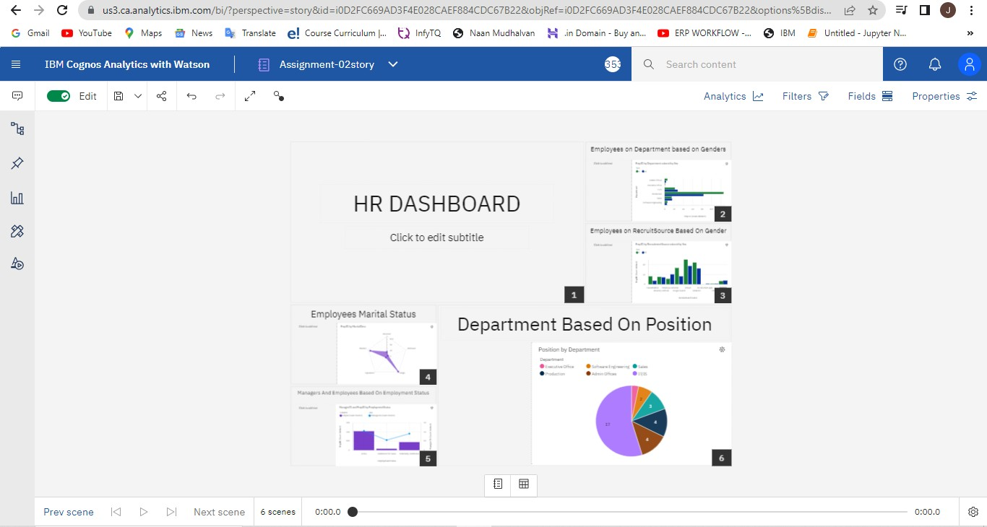

1. 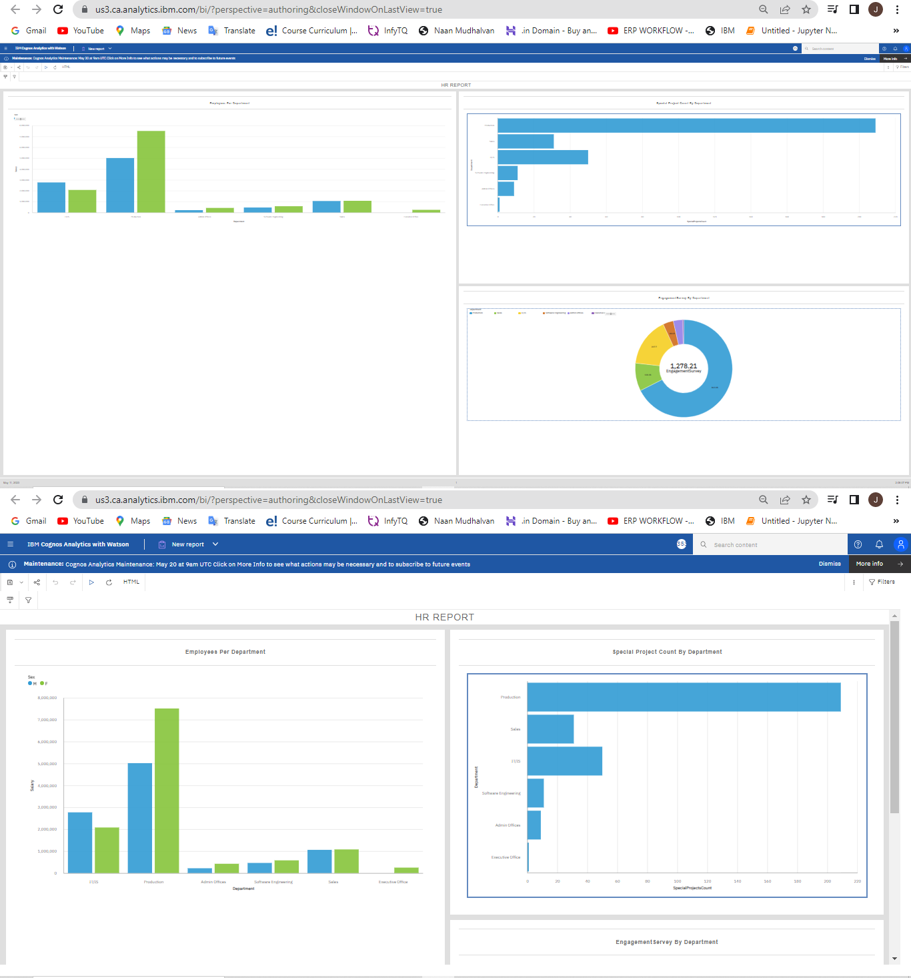**Create Report**

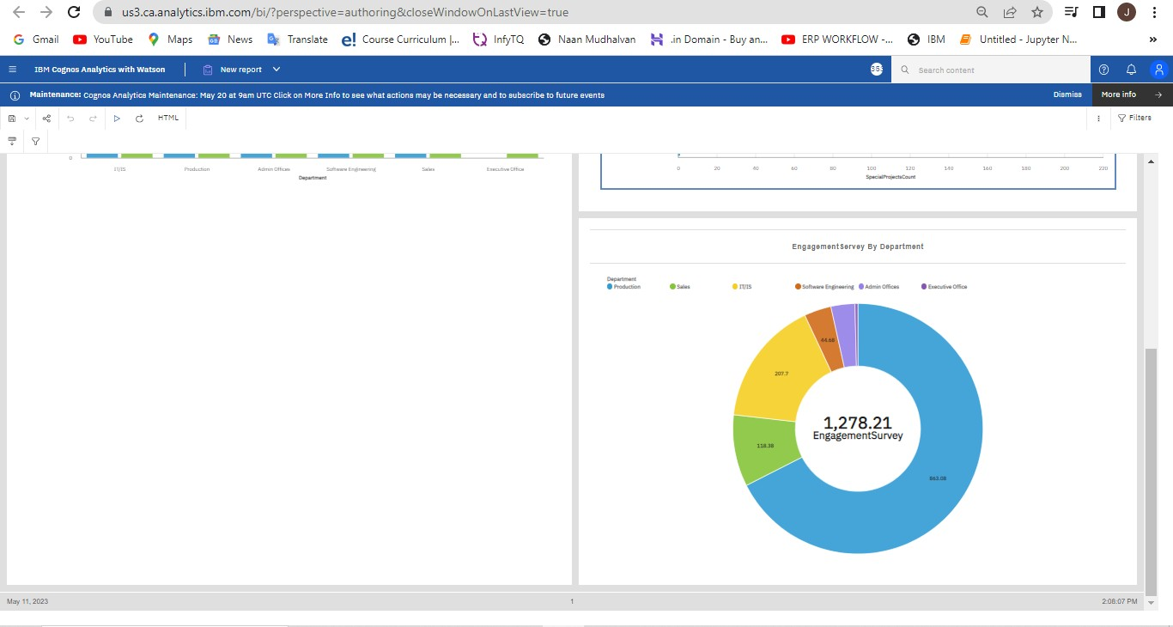

1. **Create Dashboard**

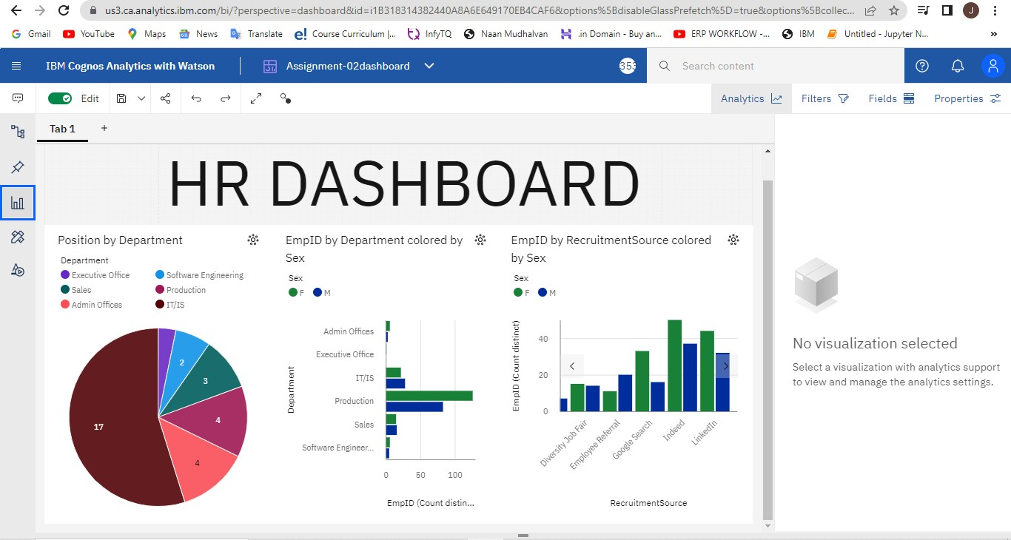

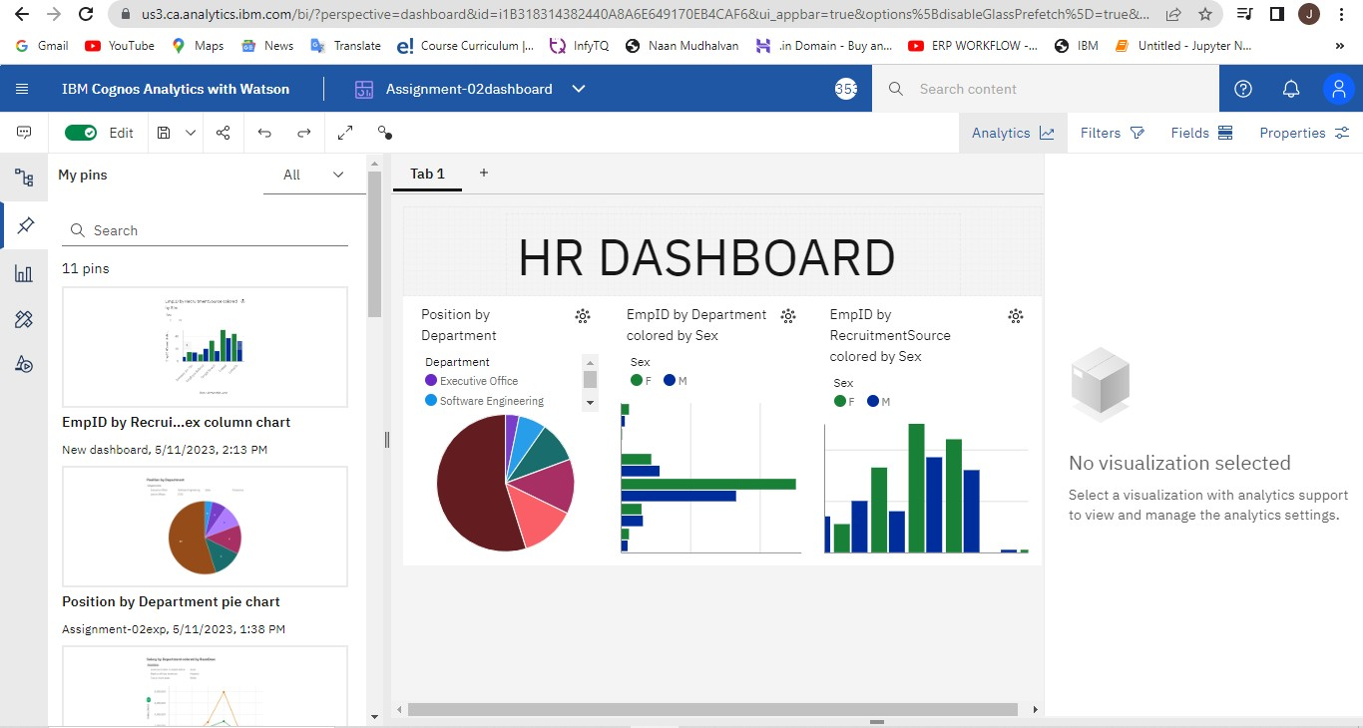

# By,

**B.ISHWARYA**

# REG.NO:950320104008, BE CSE III YR VI SEM, GCOE.